1-1_Request-response cycle

Saturday, August 21, 2021

9:34 AM

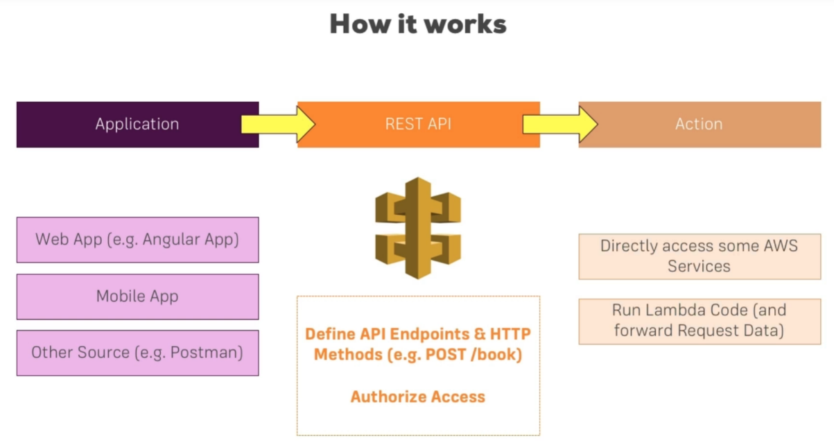

Stages are like a snapshot of API

Model -> JSON schema language, how it should be structured

Binary support sending files along with the request

Dashboard -> logging, measure

Resource (path) + method (type of request) => End point

flow of data in our API





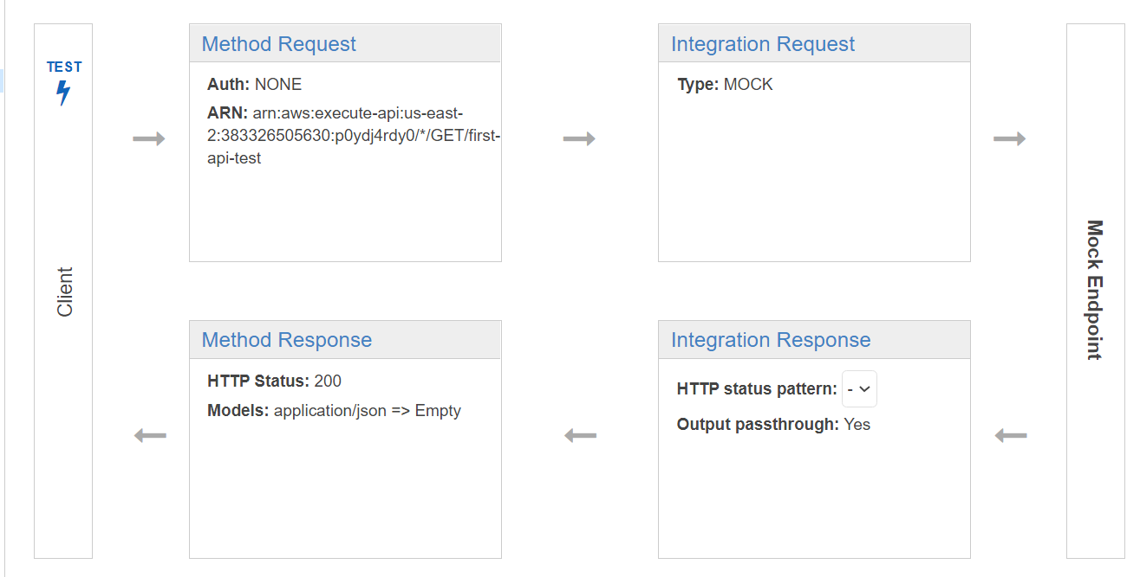

0

How request reaching this endpoint should actually look alike

It's like a gatekeeper, we can't reject request if it doesn’t meet certain schema

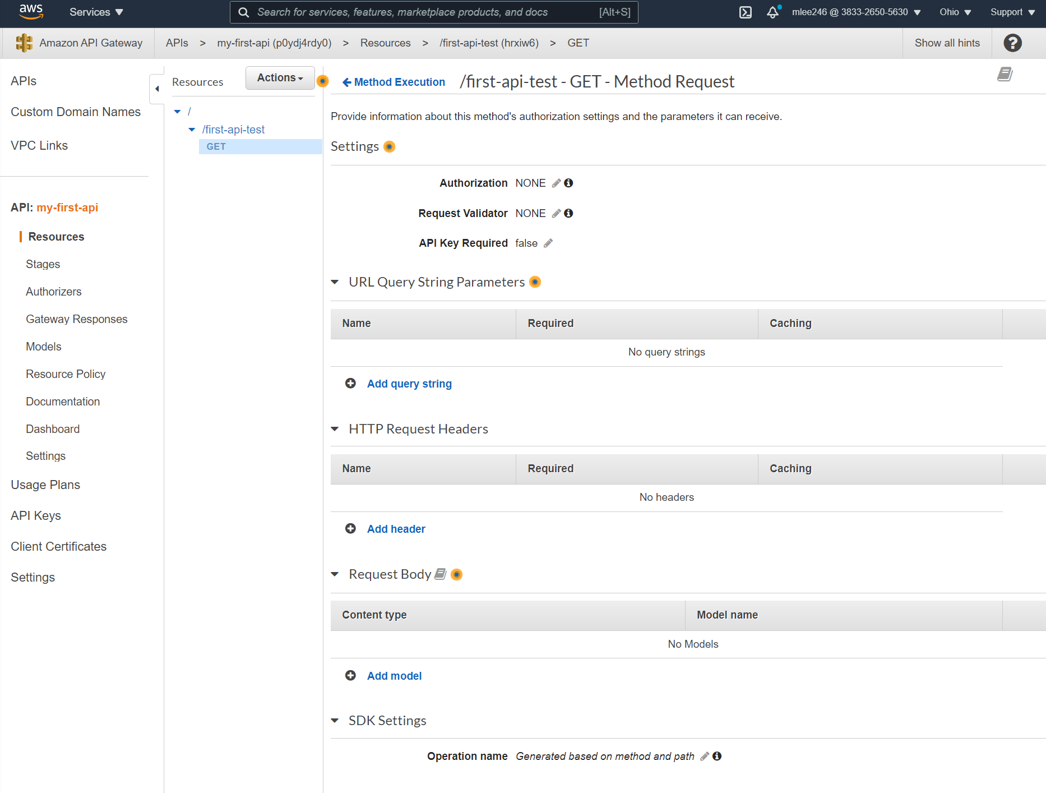

)7



rdl용개처니

Method request ensures that incoming request have a certain shape or certain data that meet requirement

㉣

Once the request made through the gatekeeper (method request) then we reach integration request. Here, mapping or transforming incoming data into the shape we want to use it on to the action we are about to trigger

Services Q Search for services, features, marketplace products, and docs (Alt*Sl 
Amazon API Gateway APIs > my-first-api (p0ydj4rdyO) > Resources > /first-api-test (hrxiw6) 
> GET 
@ 383&2650-5630 Ohio support 
Show all hints 
APIS 
Custom Domain Names 
vpc Links 
API: my-first-api 
I Resources 
Authorizers 
Gateway Responses 
Models 
Resource Policy 
Documentation 
Dashboard 
Settings 
Usage Plans 
API Keys 
Client Certificates 
Resources 
Actions. +MethOdExecutjon [first-api-test- GET - Integration Request 
Provide information about the target backend that this method will call and whether the incoming request data 
'first-api-test 
GET 
should be modified , 
Integration type O 
O 
Lambda Function 
O 
o 
Mock O 
O 
AWS Service 
O WC Link O 
Mapping Templates 
Request body passthrough @ 
When no template matches the request Content-Type header O A 
O 
When there are no templates defined (recommended) O 
O 
Never O 
Content-Wpe 
application/json 
O Add mapping template 

Integration Request allows extract data from incoming data and pass on to the endpoint

30

Similar to Integration Request, this time other way around, this allows configure our response sending back

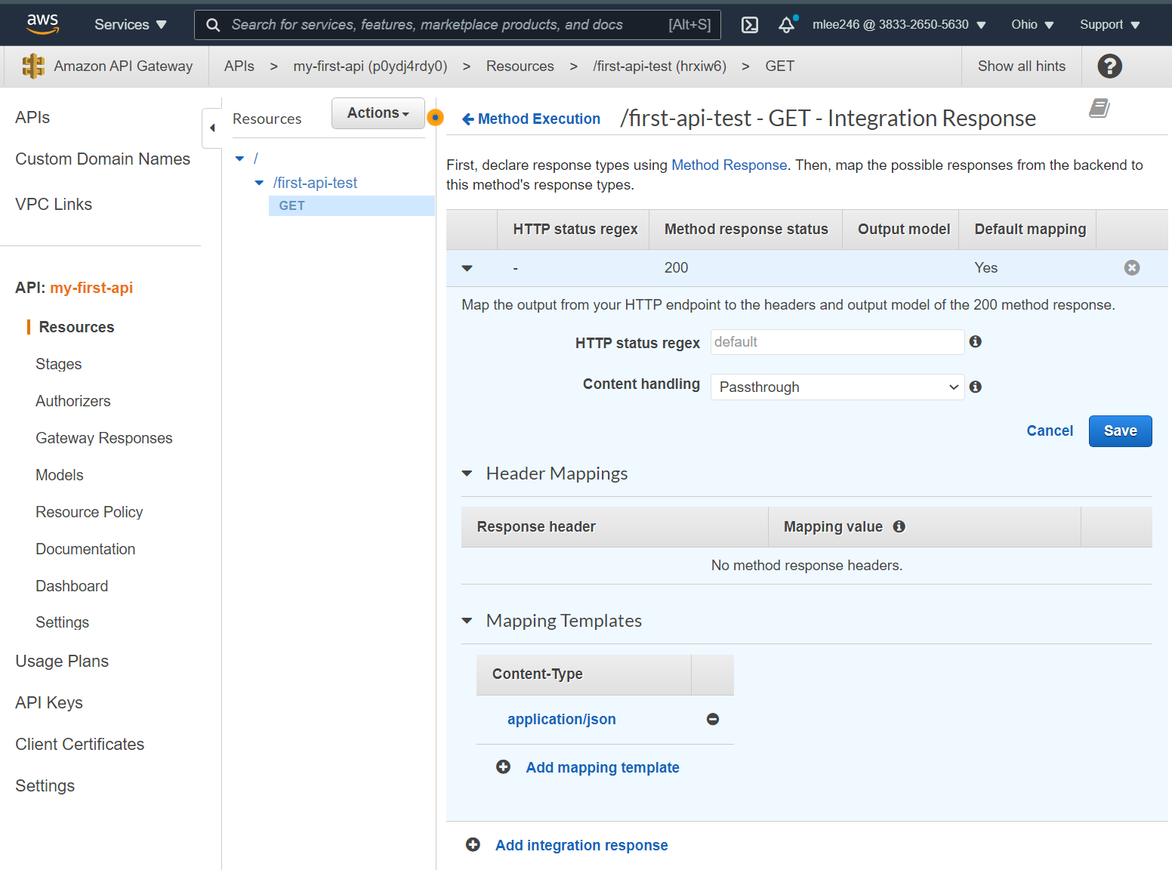

빠add

』

Similar to Method Request, this time it's NOT gatekeeper, but it defines the shape of our response. We can configure possible responses;

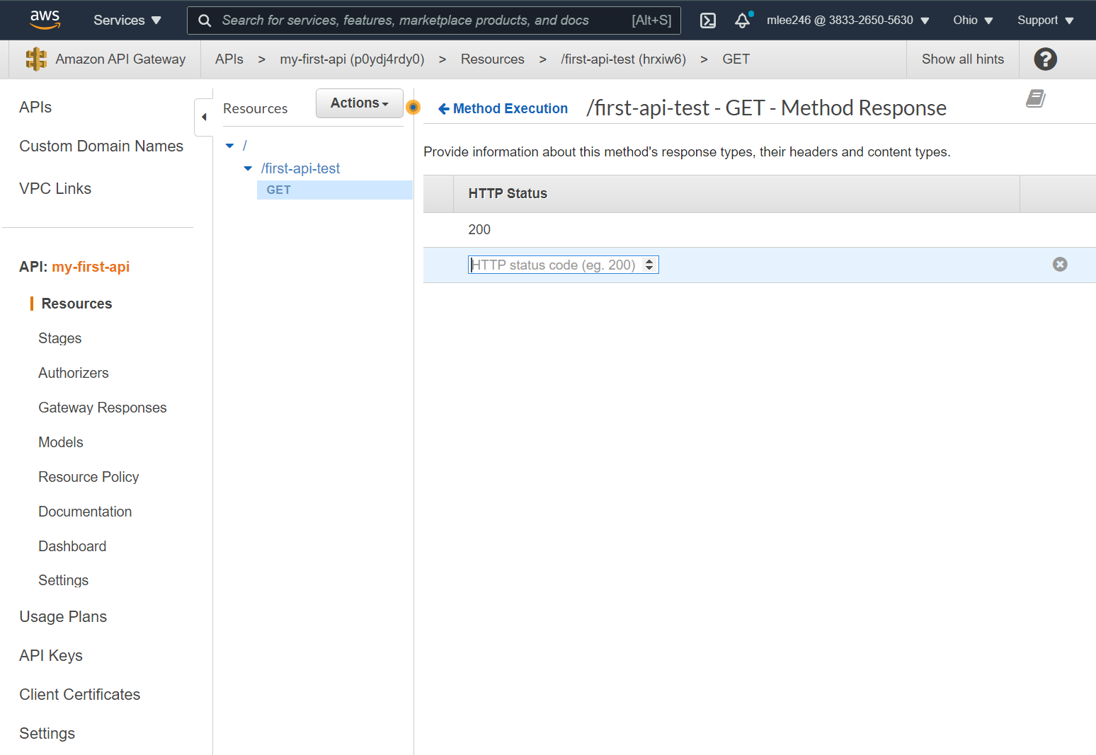

Method response defines the shape of response, integration response fills that shape with life, it's non-binding. We can still send different responses because we can't block that response, we need to send one in the end

We NEED this for headers since we cannot set values for headers in integration response.